Wednes-DEE! March 16, 2005
"Where's the old guy?" Buzz was not in the news room. "The old man is late for the party. Oh, look he's back." "Hello, Buzz." "Hi, Don and Mike." "What's up with the tight shirt?" "You like the clingy?" "Are you vagarious? I'm Larry from the corner." For the next 5 minutes, Don, Mike and Robb did their very own impersonations of Larry King. "Are we kitchen sinking?"
Then, Gay Billy Big Voice. "Oh, he's back. And he sounds bad. Deeper." Gay Billy Big Voice explained he was sick. "Michael, Big Voice -out."
"Hey, now!"
Let's get retarded.....
"Robb, you hair is looking more English soccer thug- esque." "We have a phone call" "No, Mike. We have an e-mail." Don read an e-mail from comedian Frank Caliendo. In this passage, Frank said that Don and Mike were responsible for 95% of his audience at the club in appeared at in Wichita. "Thank you, Frank."
"And I know you don't watch the Idol, Buzz...but I've got to take a minute to complain." Don, Mike and Robb all felt that the musical selection by the American Idol contestants sucked last night. "But, my girl, Nadia kicked ass last night.", said Don. "Phone call" Hello, Don and Mike Show. "I just wanted to explain about the horrible musical selection. It's because Fox is so cheap, they only take songs that they can get for free. The better ones would cost the network." Don called back to Joe and Beth Ann and asked them to do some research on the subject. Ryan Seacrest's hairdresser, Dean Banowitz, confirmed the callers theory.
"Let's talk football. The engineers at this station are all in an uproar because of the exclusive Joe Gibbs interview. Yeah, real exclusive. Gibbs whored himself out all morning on every radio station with in a 100 miles radius. Real exclusive." "We got a phone call." "No, it's Joe's e-mail. I got this the other day...here's what it said.
HEY EVERYBODY!
Please visit my website, www.joeardinger.com, and download my latest release "Mid-Winter Song" for FREE! Yes and then proceed to put it in your IPOD, or send it around the globe to your family and friends! Put it on Kazaa or Napster if you like! I NEED YOUR HELP TO TAKE THE "INDUSTRY" out of the "MUSIC INDUSTRY"!
Anyway, thanks to all for e-ing me over the past couple months since I released "Mall Traffic". Your response was greater than I thought it would be. Please tell your friends and link them to my site! I have had some conversations with friends, (and even family), who say I should charge you to download my music. I can say at this point that I just don't think I'm going that way. Actually I'm sure I'm not. Hopefully in May 2005 I will release an EP, entirely for free. I am convinced that this is the way of the future of music. Call me crazy or not, just e-me back regardless.
As you may have noticed, there is a button on my website called "Buy Stuff". Soon you will be able to buy some stuff, but not my music! I am coming out with a very cool Joe t-shirt that I designed and will be silk screening myself, and other funny stuff too. More on that later, but the bottom line is that if you want to buy them you can, if not, that's fine too. But you gonna want one! That's all I can say!
On a technical note, please realize the when you download an mp3, as my songs are, you can change the way it sounds with some simple adjustments in your software, depending on what you have. That way you can get the full range of the recording. I know that my web guy, (one of the best), has allowed for it. I have done it myself. So enjoy that aspect of it if you are so inclined.
In closing, I've had hits to my website from a lot of interesting places in the world. Thanks to the .gov people from around the globe. Also thanks to the .edu people as I know that school can be tedious whether you're a student or a professor. I know some of you media cats are checking in as well. I especially love the hits and downloads that are obviously coming from the workplace. Use your company's high speed to burn the songs to disc or whatever! Stick it to the man, I won't tell. One thing I would love confirmation on is that someone is sending these songs over to our soldiers all over the world. Actually, just tell your sons, daughters, mothers, fathers, to come home safe, and come home soon.
Until May or so... thanks again!
joe ardinger
Don read the only thing and then played a bit of "Mid-Winter Song". "Now, remember, Mike...he's not charging for this. "I just have one bone to pick with Joe about this song..." A call back to Joe. "Hello, Joe." "Hello, Don and Mike. How can I help you two gentleman?" Don told Joe that when you go to the lyrics section of his website every time the word "your" is typed, it should be "you're". "Oh, I'll have to talk to my webmaster...he does his best. But, we are working on a shoe string budget."

47:54 = "God, this one's for me", said Don. "I do love Batman..and on the phone with us right now is John Azarian who owns one of the original Batman suits." "How much is it worth?" "300 thousand dollars." "Have you ever smelled it?" "No" "Would you ever god forbid let me wear it." "Yes, I would." Don fainted. Not really, but he wanted to. John also has the Robin suit, part of the Batgirl costume, the Lost in Space suits, and a bunch of other stuff. "Where is the suit now, John?" "It's in my house." "Can you rub the phone on in?" "No, cause I'm at my office." Don, Mike, Buzz, Robb and John then parted ways. Don said he was upset because John doesn't really like Batman like he does. "It's only an investment.. not a love." Don then played a cut from his Batman album. Yes, I said Batman album. I'm not kidding you this time.

1:18:36 = Don said he got an e-mail from Robb last night that has a mini-movie of Sheryl Crow taking off her clothes.... here's the website http://www.newsoftheworld.co.uk/
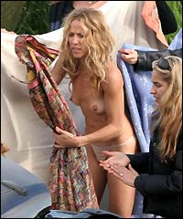
"Kevin Federline...does he stink? You bet he does. Mr. Zitney Spears said he was in Biloxi, Mississippi gambling...dripping in ice and with about 3 grand worth of chips. but, the dealer didn't notice any of this because of the stench that was coming from his body." [ moans and groans] "He looks smelly and gross. They both do." "American Idol. The virgin American Idol...Kelly Clarkson." "The corn fed American Idol." "No, Mike have you seen her new video? She looks pretty hot." "They can doctor videos"
"A feel good. For you spring breakers. Last night a drunk guy was on the second floor balcony. He and his other drunk friends were having a spitting contest. This dope thought if he just leaned over just a little further...he could win the contest. But, when he leaned over he fell. Now, he didn't die...but he did have some broken bones and bad cuts the needed stitches. So, be careful kids when you have your spitting contest's on spring break."

1:34:49 = "We are playing the Medical Information Game for the trip to Los Angeles. Who's this?" "Stephanie" "Stephanie...who do you want to play for you?" "Buzz." Mike said, "Thanks a lot Stephanie." "And who's this?" "Jim" "Jim, who would you like to play for you?" "Oh, I want Mike." "Thank you, Jim...Jim's gonna win!" So, the battle began. A call to the 1-900-medical-info line. It started with irritable bowel syndrome, then hemorrhoids, and then bee stings. "Now we need 2 new contestants." On the lines were Denise and John. Mike's chlamydia beat Buzz's rubella so, Denise is going Los Angeles for WWE'S Wrestlemania 21 live!!

1:58:54 = "More equipment problems! An engineer is nowhere to be found because of our big, exclusive interview with Joe Gibbs tonight. Beth Ann get in here with the digital camera." Don had pictures taken of what he had to deal with everyday. Go to the photos section to see The Studio. Oh, and Mike wanted his area with it's problems highlighted.
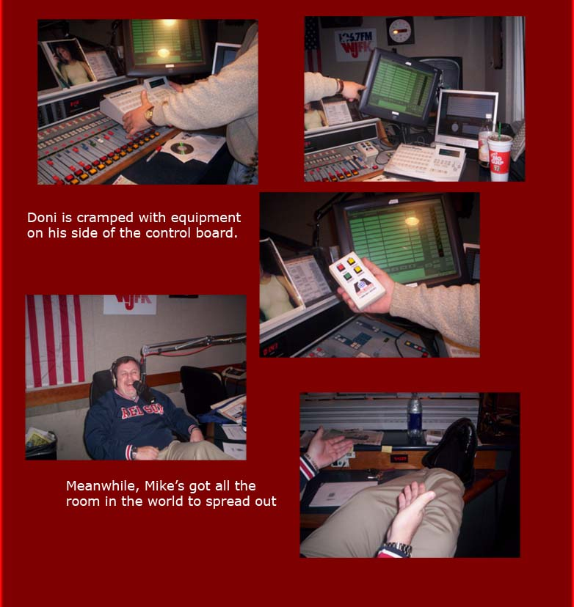
Phonescan! "Hello, Don and Mike show." Don and Mike, thank you for 10 years of laughs, I'm calling from Bakersfield. "Oh, come on ...you should really only be thanking us for about a year of laughs in 10 years. Let's be honest." Geez we gotta break...we took pictures. We will come back with a real phonescan.
Now a real phonescan! "Hi guys.. I wanted to let you know I saw the Ring 2 last night and it's not as good as the first." "Okay, honey. Thanks." "Hello, phonescan." "Hey, Don and Mike what's going on?" "You know what's going on...we're fulfilling a 5 year contract." "Hello, Don and Mike Show." "Hey, guys it's huggy bear." "Hello, HG." "You know Robert Blake didn't kill his wife...that damn bird did. The bird did it." [laughter] After several more messed up callers Don officially put an end to the phonescan.
The News and the Comments with Buzz Burbank!
The boy in the Michael Jackson case said he never spoke with Jay Leno. Jay could be called to testify very soon in the Jacko case. "Letterman must be ready to put a gun in his mouth. Leno's in the news all the time."
In the meantime, Jackson's lawyers are doing a great job of painting the accuser as a liar. And every morning Michael prays with Jesse Jackson over the phone. [Mike did his Jesse Jackson impression] "Now nobody say it sounds like Arnold." [Then Mike did Arnold] They did not sound alike at all.
Looks like Diane Diamont from Court TV has done a deal with the folks who are prosecuting Jackson. "It's an ensemble jury" [they did a spoof of Jack Diamond...a DC local morning DJ]
Jackson's jury got hot free pizza from The Olive Garden because CNN kept reporting that the jury wasn't allowed to stop to eat. They call it the Melville Diet. "I hope those jurors keep the weight off."
Robert Blake was found not guilty in the trial for the death of Bonnie Lee Blakley. He wept when he heard the verdict. "Now he can go back to that restaurant he likes so bad...ya know the one where he killed his wife."
There have been 21 murders in the "City of Brotherly Love" this week alone. "What they need is a good rock block."
President Bush has named Kevin Martin as the new head of the FCC. This makes all branches of government Republican. "I guess it just makes it easier to follow." Don asked if anyone saw Bush on his impromptu press conference today. 'He's just so freakin' full of himself. It's so funny. God he's dumb."
The state of Kansas has declared that Greyhounds are not dogs. So, now those dog races are no longer dog races. "Now come on Buzz, who would bet on a dog over a bus? A bus is gonna win every time."
It was 80 years ago today that the first topless women was shown in film in a movie theatre. "What was it like back then, Buzz?" "It was wonderful."
When the Florida Marlins turned the game around...they tell us they now attribute their success to their naked batting practice. "Baby!" "What would the count be then? 6 balls?" "And what constitutes a swing?"
Sorry, we're out of time...

