Mon-DEE! April 11, 2005
"Hello!" [Julia Spewak]
"I'm glad you have that drop of Julia Spewak before she designed our studio computers." said Robb. "There you go again, kitchen sinking....from the get go!" "But, I have a feeling it won't be kitchen sinking for long." teased Spewak.
"Hello, Don and Mike Show." "Did you see Jim Nantz totally diss Jack Nicholson at the Master's?" "Sir, we have a whole segment today dedicated to the most beautiful women in sports television today, Jim Nantz." Then Mike did his Hootie [very, very southern master of ceremony at The Master's at Augusta, Georgia over the weekend] impression. It was a like a golfing Foghorn Leghorn.
"Robb, do you have that commercial?" "I do." Don said he was glad that Hootie was in the studio. Well the truth is that it's Mike doing Mr. Hootie. Then Don played a commercial that Robb Spewak voiced about the new Virginia Lottery's "Negro League" scratch off tickets. Hootie said, "I don't understand why you two gentleman are laughing, because there was a time that I enjoyed the Negro Baseball league. "Hootie, look what Tiger Woods did to your little Master's Tournament for the 4th time yesterday." "Dawn, I couldn't have been happier to put that green jacket on that wonderful Negro golf player." [laughter]
"I just got to say, I was glad to see that Charles and that big horse faced Camilla are finally married." "I guess it's not all looks", said Mike. Don said, "You could probably dig up Diana now, prop her up and she's still hotter than Camilla." [laughter]
"Oh, by the way the engineer's have been going crazy all day today...just to have 2 microphones that work for us today so, we can have Joe flush the vicodin down the toilet...but, while we're in there... if anyone has a black light....let's see just how clean the bathroom is."
"Hello, Don and Mike Show." "Joe?" "Joe is in the other room, because this is an unscreened call." "Oh. Well, Don did you read how that guy from the Apprentice was arrested for disorderly conduct?" "Yes. Good-bye"
"Before, we get started let's call back to Joe to see how he's feeling about flushing the pills." [ring, ring] "Hello." "Hello, Joe. Are you hurting because you're going to have to flush the vicodin?" "No, not really for some reason.. it's not going to hurt very much." "Joe, what are you eating?" "Kit kats and Hershey bars." It would have hurt Joe more to flush the candy. He really has a sweet tooth.
"Tonight when I go home...I am one lucky guy...because not only will I have Freda...but, I will also have Big Freda." "Wonderful", said Mike, "I know you love that mother in law of yours.. and she adores you. I just think it's great. But, Don will you still be giving her a list of chores?" "I just want her to relax and enjoy." "Oh, she'll have it cushy." Don promised to report all the fun with Big Freda in the house. "Is she a good cook?" asked Mike. [referring to Big Freda] "I really don't know." A call to Freda. "I do know that she's loves to iron." Big Freda answered the phone. "Hello, Big Freda. How are you feeling." "I'm glad to be here and I hear that someone went to special trouble for my dinner." Big Freda said Don bought her a steak. [awww] "Big Freda...make yourself comfortable. I just wanted to call and welcome you. Love you, Mom." "Love you too, bye now."
"Let me tell you what happened over the weekend...but, I need to first re-focus the attention on the new touchy, feely engineer, Matt. He talks like the guy who replaced Barney Fife on Mayberry RFD. The guys name was Warren...we will put him on the air today and you guys decide." [laughter] "Oh, and a side bar...Freda signed me up for the DNA thing that will give you and idea of where you can from. I'm adopted so, that's why I'm doing that." Mike asked if it would help Don with his medical history? "Does it do that, does it do the greasy?" Don said in order to prepare for Big Freda's arrival, they went to U-Haul over the weekend. "I wanted to buy 5 boxes. It's around 8:30 in the morning. The place is packed with people making life altering decisions. There is a woman in front of me who looks like Joe Dirt. [laughter] She's asking all kinds of questions. And I just don't have the patience. They just seem to be finished with Josephine Dirt when the guy behind the counter says, "Okay, I just need to see your driver's license." Turns out she doesn't have one. I'm just there for the boxes....and she let's me go ahead of her. The guy rings everything up...it comes to $20.21...I reach into my back pocket and my wallet is not there. I tell the guy that my wallet is in my car. It is but doesn't have any money or credit cards in it. So, then I have to go all the way back home. I said, see you in 45 minutes. Josephine Dirt says she has 17 dollars. [awww. she's a good Samaritan] I thanked her and said I would go all the way home. I go back home, get my cards and cash. When I return Josephine is still there. She asks me if I could run her truck rental on my credit card...and I kept thinking she was willing to help me, but I'm not going to help her, so I chickened out and said, "my wife will kill me". "So, you lied to her." "No, Mike...I told her the truth. Freda would have killed me. Robb said, "And rightfully so. She never would have paid you back." Mike said, "I would have done the same thing."
"Then, I'm at the grocery store and this guy keeps coming up to me and saying hello. I try to be nice to him. But, he comes up 4 or 5 freakin' times. We both go to our cars around the same time...and then I see why this guy keeps saying hello to me....he's a construction guy that sat and had coffee with Freda and me in our home 3 days earlier." "That's funny...you didn't remember him." "Exactly." "Will you be hiring him?" "That's the thing, Mike. I don't think so...because I'm too embarrassed." [laughter]
"My best buddy, Mike gave me a call yesterday around 5 yesterday afternoon to tell me that his back was hurting so bad...he probably would not be in today." "That's right Don...because at that time yesterday...I couldn't sit to even drive a car." "It's good to have you here today...and you are standing!" "Well, that's because I can't sit very long...and I'm the gamiest I've ever been in 20 years on the air with you." "Oh, you didn't bath today?" "Nope and I couldn't even brush my teeth because it's impossible to bend at the bathroom counter." "For those who don't know, Mike is wearing a therapeutic and slimming back girdle."
"We've got some Nancy tapes from the Master's Tournament yesterday." Don and Mike played some audio from Jim Nance who did the play by play for The Master's Tournament in Augusta, Georgia. "This is too Nancy."
Don said the engineers are now just sitting in the lobby waiting for us to do the bit for the vicodin to be flushed down the toilet. "Okay, before that...I need to ask you guys if you think Tatum O'Neal is a lesbian." Mike, Buzz and Robb said yes. "Well, you're right. She met a woman at club and the two were so graphic with their smooching that they had to be asked to leave. And they did...together." [ohhh] "I mentioned that my wife is starting to buy the National Enquirer. And they have a new article that's written by Anna Nicole Smith." [You like my body? Mike said that really drunk like Anna would.] "Do you think she really wrote it?" asked Mike. Don read some. "Yes, I bet it's her...it sounds remedial enough" said Mike. "The good news is that the Olsen Twins have turned down Uncle Jessie and will not do an episode of his new show...why? Because they are just too busy. But, they are not too busy to go on tour for their new line of Olsen Twin bedding."
"A couple of feel goods. A guy from Fargo is okay after shooting himself 4 times. He keeps a gun under his pillows on his bed...and one day when he was vacuuming the pillows, the suction causes the gun to go off 6 times." [ouch!] Then a man turns up drunk and high to get his new driver's license. He gets it. But, people who witnessed him not only stumble around in the DMV...but, he had also crashed his car into the side of the building before he entered. The concerned citizens called the police...and just after getting his new license.. he was arrested...and had it taken away."
"Now, to do what needs to be done....Joe are you ready to flush Mike's vicodin down the toilet?" "And we have black lights to see how much DNA is still in the men's bathroom." The whole gang went in. Don, Mike, Buzz, Robb and Joe did it. You could hear the flush of the toilet. So sorry, Joe Ardinger. But it's the right thing. Then the lights went off and the CSI black light went on. Apparently, it's full of specimens, if you know what I mean.
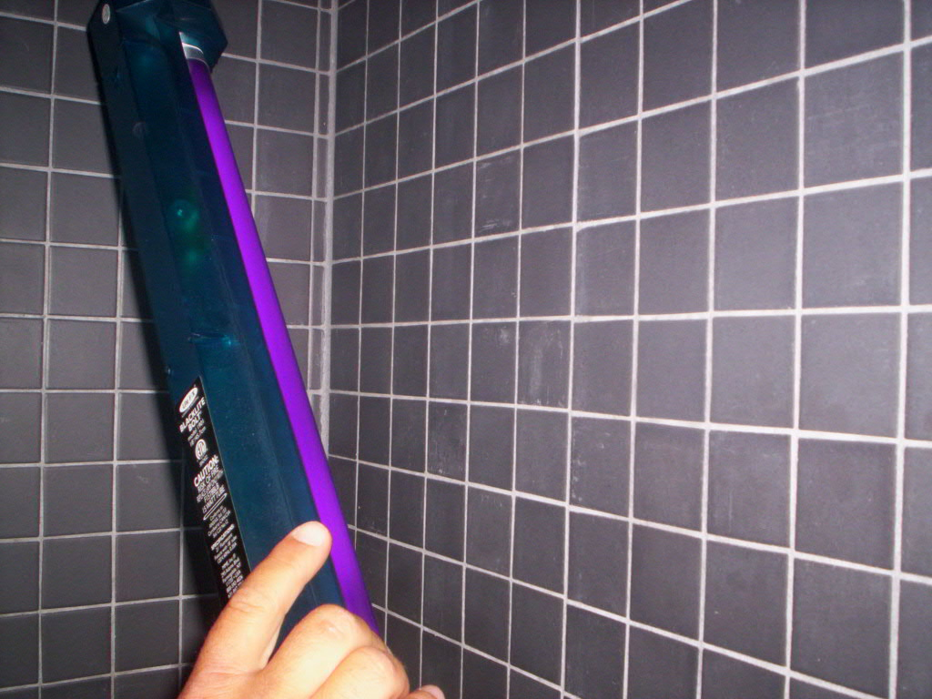
The News and the Comments with Buzz Burbank!
Just how many songs does the President have in his IPOD that he got for Christmas? Quite a few. "Think he has the new Fitty Cent on his IPOD?"
The Wiggles are big. "The gay Wiggles. Robb's kids love the Wiggles." "Yes, they will run from any level of the house to get to the Wiggles." [song...Eyes, ears, shoulders, head and toes..] "This isn't fair, we are gay wiggling during Buzz's news."
Tom DeLay is a big, stinking crook. He is accused of putting family members on his payroll and has accepted trips for favors. "The only de-lay I like is one minute and 20 seconds." [laughter]
According to a survey, Americans are not so ready for a woman President. "Come on, they're lucky they can drive." Robb said, "Only because we were hoping they would drive away."
A beer truck driver was charged with drunk driving when he had an accident driving his beer truck. [applause and more wiggles music]
Sorry, we're out of time....
The Bathroom CSI Team
