Thurs-DEE! April 14, 2005
"Hello, there.... this is Don and Mike with a new episode...and we need to start the show thanking Shady and Fleetwood from Falls Church Paving because they are already here with the dump truck. Please to be listening about what will be happening on today's show...we will be tossing my broken plasma tv over the roof into the dump truck...and then the dump truck will be empty what's left of the set and we will continue to destroy it." [laughter]
"Don, don't you think we should do a test run with something else?" "Uhhh. Yeah, I guess that's a good idea." Then conversation about what should be thrown off and who would be doing what. "Andrew doesn't know this but, he will be holding a microphone into the dump truck." "Why stop there, Don...let's have him taped into the bell of the truck with the microphone."
"Hello, Don and Mike Show." "What about American Idol and have you tried Coke with Lime?" "Don't worry, we'll get to American Idol and I only drink Diet Vanilla Coke. And I will say I can't stand that diet cherry vanilla Dr. Pepper. Too much going on...it's like a shirley temple." "Hello, Don and Mike Show." "I have to warn you guys, if you throw that plasma tv the wrong way...you could set the whole atmosphere on fire." "Get out of here, you tool. That can't really happen." "Did I mention how much I love having my mother in law in the same house with me." "Not today." "Listen, I love that woman, but she does like to talk. And of course I like to listen." "What? You like to listen." "Yes, Mike as you know.. I am a very good listener...I've been listening to you for 20 years." Don said that Big Freda loves to read the obituaries. "I need to somehow diffuse her fascination with death." Mike suggested that Don remove that section from the paper. "Oh, no...then she'll be like super sleuth looking for it...plus, she's computer savvy so, she could just go on line." "Oh, no did you see that? Someone died in Denver..." [laughter] "Hello, Don and Mike Show." "Don and Mike the reason people read the obituaries because they check to see if any of their friends have passed away." "No, duh sir. That's pretty much what we were saying." "Guys, be nice to me because I'm blind." Don, Mike, Buzz and Robb didn't believe the guy and gave him a whole "are you blind" test. After several questions, Don and Mike found out that he was legally blind and not Ray Charles blind. "What ever you do to get the ladies, is okay with me." "That took an interesting turn." "What do you mean?" "A blind turn." [laughter]
"Oh, we have a bad caller update...we just had to put a guy in the book...and he's here on the phone." Robb said, "Darryl, your number is zero zero zero stroke zero zero three six." "Wonderful." "Now, let's go live to the roof of our building where we have Joe Ardinger and a test computer." But, before Joe could utter a syllable...the guys talked about music. "Oh, god I hate the Drifter's...the only reason we are playing this is because Joe is up on the roof. Let's go live to Joe. Hello, Joe are you there?" There was no response. "Robb, go up and see what's wrong." Robb went up and found out the microphone was not working. Finally, Tony Diggs fixed the problem. [drop Tony Diggs...bicardi limon] "Joe what's going on?" "Well, it's kinda of windy and there are already some people hanging out to watch." "Thank you, Joe. We'll be back later."
"Now, let's talk about Idol. Freda even got mad last night...there were just too many phone calls over the princess phone. And thank you America for keeping full metal jacket boy in." [applause] The bottom three were Nadia, Bo and Scott. "Hello, Don and Mike Show." "I just hate that fat boy with his fat hands holding the microphone...come on who's voting for him?" Don said, "I am...dozens of times. I love him."
"So, here's my blog today...it's about DCRTV...just something real quick. I don't mind people having their opinions...but, the guy who runs it is not a fan of the show...but, please at least have some guide lines...that's all I ask. He claims to know radio, but lets anything fly, no matter how inaccurate& it's the wild, wild west. Thank you."
"In about a half hour we will be throwing my broken plasma tv off the roof, but not yet...first we have a Charlie Stuangstavelack Interview." "Hello, Don! Hello Buzz...hello Robb. I'm wearing my safety goggles!" "Charlie, now today you will be talking to guy who has a really big thermometer." "Goody! Wait, I gotta take my goggles off." "Go ahead Charlie. Now remember when you used to live at that place for long time, how many times did they take your temperature?" "One in the morning, twice before lunch, after lunch 3 times in the afternoon, before dinner, after dinner and twice before bed." "That's about 11 times a day. " "Yes Don, and it was always normal! " "Okay, let's call the guy now." [ring ring ring] "Hello. This is Larry" "Hello, my name is Charlie and I want to talk about your big thermometer." "Okay." "Larry Debor, who's idea was it to get the big thermometor? And Larry, please always say my name, Charlie...okay?" "Okay, Charlie." [applause] "Larry what do you sell at your business?" "Charlie we sell food, cause it's a restaurant." "Mmmm food...what kind of food do you sell? Do you have pizza?" "No, Charlie, we don't." "Why Larry Debor..whhhhyyy?" "Because we serve things like meat loaf, mashed potatoes and stuff." "Oh. Larry do you like having the world's biggest thermometer?" "Yes, Charlie." "Would you be mad if I built a bigger one?" "No, Charlie I wouldn't." [laughter] Don then suggested that Charlie talk to Larry on the phone off the air. Charlie did a whoopsie. "Larry, I wear a girdle."
"What is Robert the mailman doing here?" "Mike, we're having an event so, of course he's here. But, I gotta say Robert mailman is much more reliable than Dennis Murphy. What do you think are the odds that Dennis will actually go to the National's game and tape stuff of him asking people wacky questions?" Robb said he might do it, but there is no way the tape would be delivered by 9 tomorrow morning. "Never in a million years."
"Now about American Idol, again. If you remember, Mike...my gay-dar went off early with Anwar." "I remember, Don." "Turns out before he was on American Idol, he posted a single's ad on a gay website www .afterelton.com" "Oh, my." Don said another gay website, Blackplanet, also had Anwar as a visitor in January. "Well Don you can't blame American Idol...they never had a gay person on the show before." [laughter] "Right, like Clay wasn't gay."
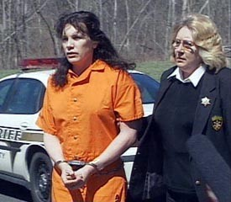 | "Time for just a feel good. A man who had a sex change and became a woman killed his mother. This is the first time in American Justice history that a person committed the crime as one gender but, was convicted as another."
"Boy, Don I've never seen Robb so happy...he and you on the roof. You've made that boy happy." "Oh, god, I hope sweetie is home." [ring ring ring] Freda said that Don and Robb were like little girls talking on the phone during American Idol. "I'm getting the whoopsies." said Mike.
"As we promised, we are on the roof getting ready to drop my broken plasma tv off the roof of the radio station." See the pictures...be looking soon for video!!

Plasma TV Destruction

The Dumptruck pulls up to the station. | 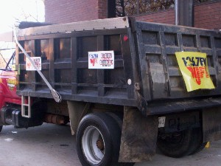
Don and Robb wait to drop. | 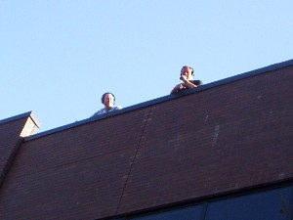
Listeners run for cover! | 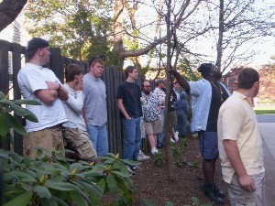
Don takes a test run with a monitor. | 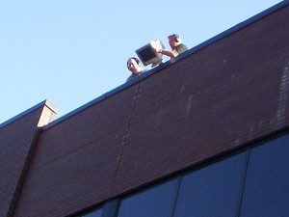
Mike bravely stands in harms way. | 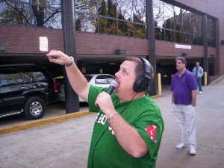
Now it's Robbs turn. | 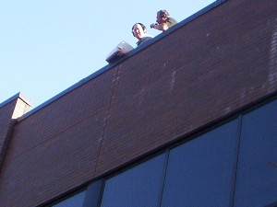
Mike and Buzz's afterglow. | 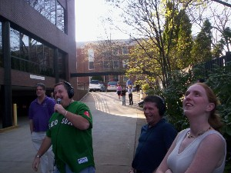
Plasma TV nears the edge! | 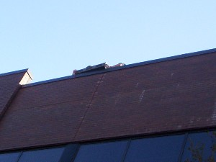
Bullseye! | 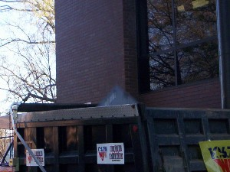
Tarp is ready to receive this destruction. | 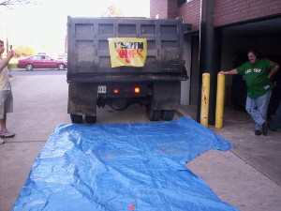
It's broken, allright! | 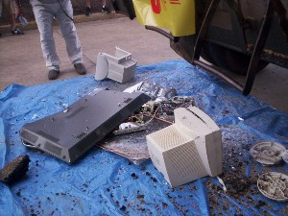
Don examines the evidence. | 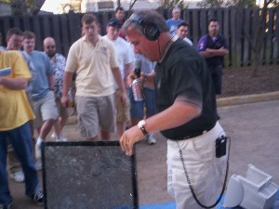
Don finishes the job. | 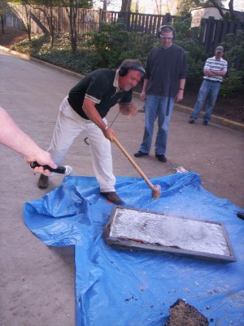
The End. | 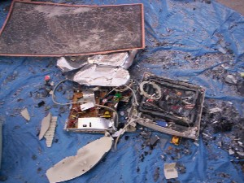

The News and the Comments with Buzz Burbank!
Some Americans are now using their moon shine as gasoline. "What a tremendous waste of alcohol!" It's cheaper than the traditional method and some people are selling moonshine kits for about 200 dollars. "I'd make it, but I'd drink it before I got to my car."
The airlines are trying to find ways to survive and profit. Southwest Airlines has been hedging on their gas. "Oh, that's nice to know." "Maybe they should just get a moon shine kit."
Our homeland security dollars have been spent on....segways...you know those 12 mph scooters. Don and Mike said when they first saw on in New York..it was the strangest thing. "I really thought they would be the wave of the future. Then you realize how idiotic they are." "Wish I had one to throw off the roof."
Don and Mike started to talk about people merging on local roads. "I saw this guy trying to merge and no one would let him in.. and he kept running over the orange traffic cones. I mean no one would let him in." "God, what is that smell?" "It smells like somebody farted." Robb said he broke some kind of vial that was sitting behind a box. Buzz said, "It's a stink bomb." "Who put a stink bomb in the studio and why?" "You know who I think it is, Don?" "Who, Mike?" "Well, who I always blame it on.. Greg Edger!" [laughter]
Sorry, we're out of time....

