Wednes-DEE! May 4, 2005
"Starting today with a little Aerosmith!" [music jammed] [drops of Rosie from her retard movie] "And Mike and Buzz had their big motorcycle lessons this morning.... and now each of them are putting their do-rags on." [sfx of Mike burping] "You both look like an extra from Malibu's most wanted. Looks like you could be in a new gang, the fags." Don said to take a picture for the website. Joe came in and took the picture. It's on the photos page under Motorcycle Men. What do you think?
"Hello Don and Mike show." "The company you work for...pretty much sucks." "Wait someone has a bulletin." The caller said they pulled the plug on WQSR in Baltimore. "It's now Jack FM."
[laughter] "Hello Don and Mike show." "With Mike and Buzz's motorcycle lessons...who's gonna play Pinky Tuscadaro?" [more laughter]
"Here's what the ratings party was like last night. It was like a work release party." Don said that when he got there, there was no one from programming. But, I talked to the pixie haired girl." "You were talking to Meredith." "She's nice.", said Buzz. "Well I asked Meredith who everyone was and she said, "Don't you know anybody? No I never see anyone!" Don and Mike both said that the tension was thick. "Let's give a call to Julie Follmanl." Julie did indeed confirm the tension. Then a call to sales guy, Dave Howard. "Dave, what did you think of the ratings party last night?" "I think the food could have been better." [laughter] "Thanks, Dave Howard. You have been given the job to telling Senior Hughes that this party sucked and to make the next one better." Dave took on the responsibilty and mentioned that he thought the best place for a party was O'Meara's. Sales guys know just what to say.
"How's yours mother in law? Big Freda asked me what I was gonna do for Freda's 50th birthday. Big Freda told me that Freda doesn't want a party only because she's afraid she will get sucked into the planning of it. But that her 50th is the most important birthday and I really should do something." "Well, Don what kind of party is that...if you have to plan it yourself." "I know Mike... so, this morning I asked Freda flat out if she wanted a party. She said, flat out...she doesn't...which means of course..." "She wants a party." said Mike. [laughter]
"Hello Don and Mike show." "Hi, Don. Hi, Mike...Last year my girlfriend said she didn't want a party for her birthday...but, turns out she did." "What birthday was it?" "21st" "21st? Geez, I've never heard of a 21 year old that wants a birthday party....in my experience...they only want to get to a bar."
"Hello Don and Mike show." "Mike when your girlfriend turns 21, will you throw her a party?" Don hung up, but there was laughter.
"Hello Don and Mike show." "Is this Don?" "Yes, this is Don and Mike. We are both here. How can we help you?" "Have you seen that show Intervention?" "There's a show called Intervention?" "Yes, and there are some really tense interventions." "Well, we could have an intervention with Travis Bickel needing to pour over porn while manning the dump button for our show." [laughter] "Hello Don and Mike show." "Hey boys. I heard on a trivia show that Al Pacino turned down the role of Hans Solo.... could Mike do his impersonation of that?" "What is it, 'pick your bit' day?" "How's your mimicry?" "Hello Don and Mike show." "I met Kevin James the other night." [applause] "How did you meet Kevin James?" "I was at his show and I screamed out 'Don and Mike rules'." "Is that what you said, Don and Mike rules?" "Hello Don and Mike show." "Don since this is mimicry day....could you do your impersonations of Jay Leno blended with the runaway bride." [lots of laughter]
"Wait, we have not talked about American Idol yet. I cannot believe that." Don said the bottom three would be Carrie, Trache kid and Scot Savol. Mike said Trache kid, Vonzell and Bo Bice. Don said Scott Savol will be out tonight and Mike said Trache kid would be out. "That's a big prediction from you....saying fat boy will be gone." "Hello Don and Mike show." "Are you two guys gay? Both watching American Idol. Does Freda know she married a homo?" [homo drop] [laughter]
"Hello Don and Mike show." "Homo. That's a good program right there." "What are you talking about?" "My mom's got it bad. " "What does she got bad." "The whore-ness." "You means your mom's a super whore?" "Maybe not a super whore, but a whore to the 10th power." [sfx buzzer] "Dude, you're disqualified." Then Don played the Rosie tapes...while Mike replied to it.
"We've got something special today. Mike it's Craig Wilson's final word." "He's writing again!" Gay sounding Don and gay sounding Mike read word for word from the USA Today....Craig Wilson's column, "The Final Word." You can read along http://www.usatoday.com/life/columnist/finalword/2005-05-03-final-word_x..htm or listen to the D&M version on today's Audio Highlight.
"Hello Don and Mike show." "Is this the official outing of Craig Wilson?" Don, Mike, Buzz and Robb said that in all the years of reading his column...that was the first time Craig called himself gay. "Hello Don and Mike show." "Don, Mike wanted to let you know that I was on line today...and there was a whole line of maternity prom dresses." "Dear god!" "Now, Mike maybe this info might come in handy? How old are your girls?" [laughter] "Stop it , stop it Don"
"The latest cheap format of radio is the Jack format...the premise of the format is that they will play anything. Robb, where's that press release?" While Robb looked for it....Don played 4 very different musical cuts that would be found on 4 different radio stations. "Wow, I liked 3 out of the 4." Robb found the press release. "See they say they can play anything, but they're really not." Don went from Smash Mouth to Jim Stafford to the Barenaked Ladies to the Osmonds. "I must say Don, I liked the first cluster better." "Hello Don and Mike show." "What does Jack FM mean and why do they change stations that were already good?" Don and Mike said they wished it could just go back to the way it used to be. "A box a records and a jock who picked what he played." "Hello Don and Mike show." "Don, Mike remember back when the FCC was all up in a tizzy about Janet Jackson...and you didn't know what you could say and what you couldn't....and you played music?" "Yes." "Well, that was the best 4 hours of music ever!" "Oh, Don...someone is giving you a compliment!."
"Tomorrow Buzz and Mike will be evaluated for their motorcycle course. So, we will find out about that. That's tomorrow. Tonight is ABC's expose about American Idol. I don't want to ruin it for anyone but, the racy voice mails...were not sex calls, but just a call where Paula tells Corey not to say anything."
"Mike, here is another picture you want to check out on our website. We both don't like Bill Maher. And the woman that sued him for money... because their relationship was over... Coco Johnson. Well, the judge said no money for Coco." And here is her picture.

Mike said, "I love you, Coco." [laughter] "Mike, Richard Gere." "How's your gerbil" "No, Mike it's how's your dystrophy." Don told the story that 2 kids with muscular dystrophy from the Make a Wish Foundation were at a black tie function where they wanted to meet Richard Gere. "But, he said he was hard of hearing and everybody had some problem and wanted to finish his dinner. You know how they finally got a picture with the kids with Richard?" "No." "They blocked the exit door with their wheel chairs." "Oh, my god he's an ass-hat!"
"And here is the Lynndie England picture. Her lawyer said she was deprived of oxygen as a newborn and can't make proper decisions. Here she is not making a proper decision. Case closed!"
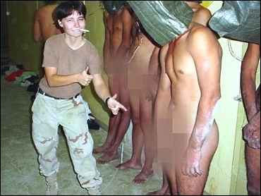
"What do you think the yearly salary should be for a stay at home mom? Mike?" "I will say $11, 500 a year and no allowance for food." "Mike....it's $131,000 dollars a year." Mike and Robb said that their should be a yearly evaluation. [laughter]
"2 feel goods. In Freedom Pa...there is a fight between deaf people....so at first they were just signing with their hands....until...one went into the bedroom and got a gun and shot." "And no one heard the gun." [laughter] "Spotlight on my best buddy, Mike. A restaurant owner was fined for painting over the body of a dead rat on the floor of his restaurant ....instead of cleaning it up. And that was the floor right outside of the kitchen. But, Mike the good news...is that the restaurant is still open." "Well, Don as a business owner myself....you gotta do what you gotta do." [laughter]
"Time for How's Your Mother-in-Law?" Don said they wanted listeners who are married....and have a mother in law that they could get in touch with to call in. Don and Mike would ask a series of questions to the listener and then call the mother in law to see if she can match. First Don demonstrated by calling his own mother in law, Big Freda and asked who was the man that Freda should've married if she hadn't married Don. Surprisingly, all the guys guessed Chris Core. Don thought it was her high school boyfriend, Sam. Guess who got it right?... everybody except Don! Chris Core was the man big Freda picked. Then Don let the listeners have a try at the game. "How's your mother in law, Dan?" "She'll say I'm obnoxious." "What's your mother in law's name?" "Connie." It sound remarkable similar to what we call some women. [laughter] Don and Mike called. "Hello Connie." "Hello." This lady sounded just like the typical sweet old granny. "The first question is what don't you like about Dan?" Connie said, "He drinks beer." [buzzer] "Connie Dan said he was obnoxious." "And Connie what did Dan say he doesn't like about you?" "Because I tell him what to do." [buzzer] "Connie, he said he doesn't like your dog." "Oh." "Connie the final question.... when you first met Dan where you A. impressed B unimpressed C highly disappointed "I was impressed." "Oh Connie, Dan guessed that you were highly disappointed." [buzzer] Don and Mike were so won over by sweet Connie...that Dan got the trip to Vegas from Fly I dot com and Connie got a mother's day bouquet from 1 800 flowers dot com
The News and the Comments with Buzz Burbank!
"Buzz you brought it with you." Buzz was wearing his hair net from yesterday. Here's the picture.
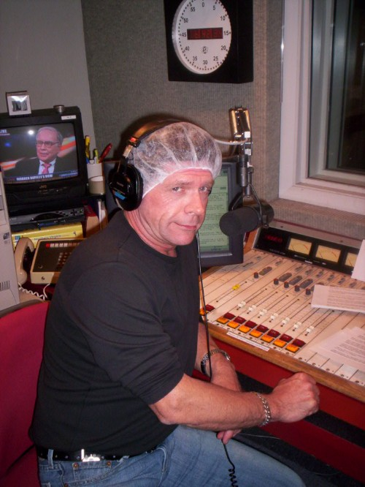
We may be close to catching Osama....we have just arrested another of his inner circle. "But how many times have we heard that?" "And they are always saying that nowhere in America is safe...the St. Louis Arch, the statue of Liberty and my wife's 50th birthday party."
A Pentagon analyst illegally gave secrets to Israel. "What's the deal? They are our allies." But he gave stuff that the US didn't even want allies to know. "Oh."
Pat Tillman got killed by friendly fire and the US tried to cover it up. "I think it's terrible...he was a hero for just going over there...no matter how he died." "Agreed." "And if you go to the Arizona Cardinal's website they are selling Pat Tillman memorial jerseys" "The NFL should ban that and let Ron Mexico slide." Mike said he wouldn't have a problem if the money was going to a charity. Don went to the Cardinal's website to find out. "No, Mike. Doesn't say any of the 64 dollars goes to charity."
A pilot in Ohio was arrested for "pulling back on his stick" in public.....if you know what I mean. "Oh, yeah!"
Theatres may now be posting the actual start of a movie...not when the commercials start. "I like that." Mike said, "I have mixed emotions.... because with a 7:05 movie...I know I have about 20 minutes before I really need to be there." Buzz then sang along to the Lowe's theatre jingle. "I love Lowes", said Buzz
A German good Samaritan pulled over to help a stranded motorist.... hooked the clunker to his own car and proceeded to travel at speeds of up to 100 mph to get him home. [laughter]
Sorry, we're out of time....

