Thurs-DEE! May 12, 2005
[music "Jesus is just alright with me" by The Doobie Brothers]
"Nothing like starting the show with a tribute to Robb's favorite Jew." "The J-man...a carpenter." Robb then started the show with his usual good afternoon and all the ships at see with many inside references. Don said, "He's only on the mic for a minute... and even I don't understand what he's saying." "We call him the insider", said Mike. [laughter]
"Hello there Don and Mike show." "I just thought the Elvis movie would have been better if they had had Marc Addy play him." [laughter] "The listener wins the Marc Addy award." Don, Mike, Buzz and Robb were all disappointed by the Elvis mini-series on CBS. "They completely cut it off before he became the Elvis we love....the purple Elvis." "Hello Don and Mike show." "Priscilla, who had a lot to do with the mini series, was on Letterman the other night. She's had a lot of plastic surgery." Don and Mike called her The Joker. "Hello Don and Mike show." [no person but, a laugh track... a lot like the joker]. "Hello Don and Mike show." "How is Matt the engineer?" "Oh, that's on the list." [sfx of dialing] [sfx of ringing] "Hello, this is Matt." Don and Mike asked Matt to come down to the studio, so they could talk to him. Matt came into the studio. "Matt have you been avoiding us the last couple of days?" "No, I was really sick." Matt then told the story about how he cried when Beth Ann yelled at him. Don and Mike tried to get to the bottom of it and wanted the listeners input, so the guys took calls. "Hello Don and Mike show." "This guy reminds me of Jonathan the sales guy, I think he might have a crush on Beth Ann." "Hello Don and Mike show." "Are you gay, Matt?" Matt said he wasn't. "Hello Don and Mike show." "I wondered if Matt has a weeping willow outside?" One listener asked if Matt would be his girlfriend. Don and Mike thanked Matt for coming in. "Thanks Matt....you're a good sport... and you gave us absolutely no information."
"Here's what we can talk about now. We can call Robert in Japan....it's his last day there. And I've got some more stuff about that creepy mayor in Spokane...but, more timely is this information we got from a new magazine called Radar. It's the 50th birthday of Disney....and this magazine is going behind the scenes at DisneyLand and Disney World. And this is stuff that Walt Disney would not like." "Oh, my." "It's all about the infrastructure behind the scenes. Who gets to be Cinderella and Prince Charming and who doesn't." "Hello Don and Mike show." "Hi guys, I used to work at Disney and lived there. It was a crazy place." The female caller said there was lots of sex, underage drinking and some drugs." "Hello Don and Mike show." "My girlfriend was one of the characters at Disney one summer... she was a face character...which meant she didn't wear a head piece....you saw her face." "So, she's good looking?" "Yes." "And you are thinking she didn't participate in all that stuff?" "No, she was always stroking my picture and crying for me." "Hello Don and Mike show." The caller told the story of how his buddy played Mickey one summer and actually had to hit a kid with "one of those big 3 fingered white hands". [laughter]
"Now we are gonna do...Isn't That Something! And let's not make this a competition." "Right, you say that now...but, you always make it a competition." Don and Mike interviewed Linc and Helena Moore.... a guy who's chicken was ticketed for crossing the road. It was so funny. Linc and Helena never got a word in edge wise. If you want to hear for yourself, listen to today's Audio Highlight.
"Buzz, are you okay?" "I'm feeling better now, but during Isn't That Something I thought I was gonna pass out. For those who don't remember, Buzz had a ruptured colon a few years back. "And it felt sort of like that." Don told Buzz to go home. Buzz said he wanted to stay. "Do you have the sick poops?" "No." "Do you have the bad gas?" "No." Buzz said he would stay and let Don know if he started to feel bad again. "Hello Don and Mike show." "Buzz, you should call 9-1-1." Buzz said no, that's very premature. Robb said they would dial 9-1 as a pre-caution. But, Mike offered to go home. And he did. Don said, "Robb, the hotline's ringing." "Don, it's Mike. I'm halfway home and I'm starting to feel better. I'm gonna head back to the radio station." [laughter]
"Leave Buzz alone, let's talk about Dave Chappelle. He's in South Africa right now being treated for an undisclosed mental issue. Sources are saying it's either drug addiction, writer's cramp or he just wants out of Comedy Central." "Oh, my god." "And, Mike Kathy Griffin may go blind in one eye because of how she has healed from laser eye surgery." "Don, she didn't just have one surgery.. she had 3." [music...the candy man by Sammy Davis, Jr.]
"These pictures today... incredible stuff. Here's Lindsay Lohan...tell me she doesn't look like an Olsen twin." "God, she's so thin." 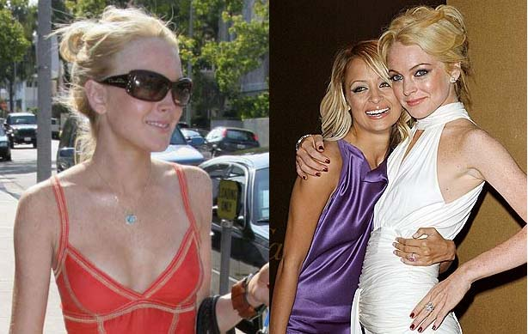
"And here's Alan Thick and his new bride." "Ohhh. Nice! Way to go Mr. Alan Thick!" Mike asked Don his feeling about the new Will Ferrell movie. "I want to go see it." "Oh, no is he your new Adam Sandler?" "Yes." Mike hates Will Ferrell and Don loves Will Ferrell. "Robb, do you like Will Ferrell." "I can't make myself like him." "Oh, come on Robb....F- yourself San Diego." Robb sort of laughed in the background. "Color me stupid, but I like Will Ferrell." [doing his from the basement of the science building voice] | 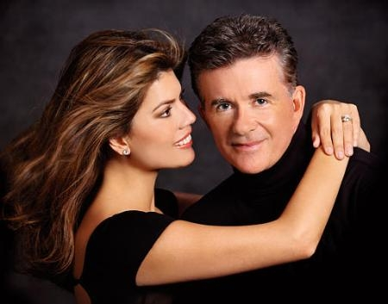
"Star Wars opens next weekend....and according to one company....it will cost the US 626 million dollars because so many will take the day off work. "Buzz.. is that what you are setting up for today?" [his talk of not feeling well}
"Time for a feel good. A 44 year old Good Humor ice cream truck driver hit a 14 year old boy in Florida who couldn't make up his mind what he wanted." "Sure, all his profits were melting."
"Buzz, how are you feeling?" "I'm not feeling very well. I think I'm going to bail out." "Go right ahead Buzz, just don't forget your doctor's note." Don said, "Well we have more time for the Highway Love Connection." Stacy from Wichita, Jenn from Virginia and Melissa from Delaware were aboard to play the game. "Sorry to interrupt" said Robb, "But, Buzz apologizes for throwing up by your car, Don." Don and Mike decided to call Buzz. He sounded awful. "Now back to the game." Jennifer won when Steve pulled over. And Melissa won simply because she never got on the air. "Thanks, Don and Mike."
"A quick call to Buzz." He was still sick, but feeling a little better. "Buzz, what is your stomach pain level?" "It's a 3 now, but was a 9 just moments ago." [Don played the Funeral dirge all during this.]
Sorry, we're out of time...

